**DAILY ONLINE ACTIVITIES SUMMARY**

|  |  |  |  |  |  |
| --- | --- | --- | --- | --- | --- |
| **Date:** | **26 June 2020** | | **Name:** | **KHATHEEJA SAFREENA.** | |
| **Sem & Sec** | **4th sem, 2nd year** | | **USN:** | **4al18cs037** | |
| **Online Test Summary** | | | | | |
| **Subject** | **---------** | | | | |
| **Max. Marks** | **----** | **Score** | | **---** | |
| **Certification Course Summary** | | | | | |
| **Course** | **INTRODUCTION TO R.** | | | | |
| **Certificate Provider** | **GreatLearning** | **Duration** | | | **6 hours** |
| **Coding Challenges** | | | | | |
| **Problem Statement:2 program** | | | | | |
| **Status: Executed** | | | | | |
| **Uploaded the report in Github** | | **Yes** | | | |
| **If yes Repository name** | | [http://shafreenasharief / lockdown-coding](http://shafreenasharief / lockdown-coding" \o "http://shafreenasharief / lockdown-coding)  [http://shafreenasharief / locked-down--certification-course](http://shafreenasharief / locked-down--certification-course" \o "http://shafreenasharief / locked-down--certification-course)  **[http://shafreenasharief / Daily\_Report](http://shafreenasharief / Daily_Report" \o "http://shafreenasharief / Daily_Report)** | | | |
| **Uploaded the report in slack** | | **Yes** | | | |

Certification Course Details: (Attach the snapshot and briefly write the report for the same)

Coding Challenges Details: (Attach the snapshot and briefly write the report for the same)

**CERTIFICATION COURSE SUMMARY:**

Today I started new course **INTRODUCTION TO INFORMATION R** through **GREAT LEARNING** the course is secluded for 6hrs. After the completion of course, certificate will be provided. I completed all the module .I attempted quiz ,which gave me a clear veiw about the topics that were thought and discussed.It consists of 7 modules which also include assessments**.**

#### 

***CODING CHALLENGE :***

Today I solved 2 coding challenge,

1. **Given start and end of a range, write a Python program to print all negative numbers in given range.**

Example: Input: start = -4, end = 5 Output: -4, -3, -2, -1 Input: start = -3, end = 4 Output: -3, -2, -1

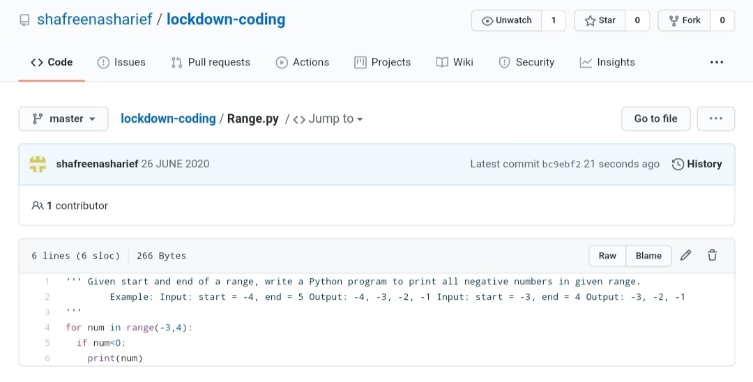

2.**Given an unsorted array arr [] of size N, rotate it by D elements (clockwise).**

**Input:**

First line of each test case contains two space separated elements, N denoting the size of the array and an integer D denoting the number size of the rotation. Subsequent line will be the N space separated array elements.

**Output:**

For each testcase, in a new line, output the rotated array.

**Constraints:**

1 <= T <= 200

1 <= N <= 107

1 <= D <= N

0 <= arr[i] <= 105

**Example:**

**Input:**

5 2

1 2 3 4 5

**output:**

3 4 5 1 2

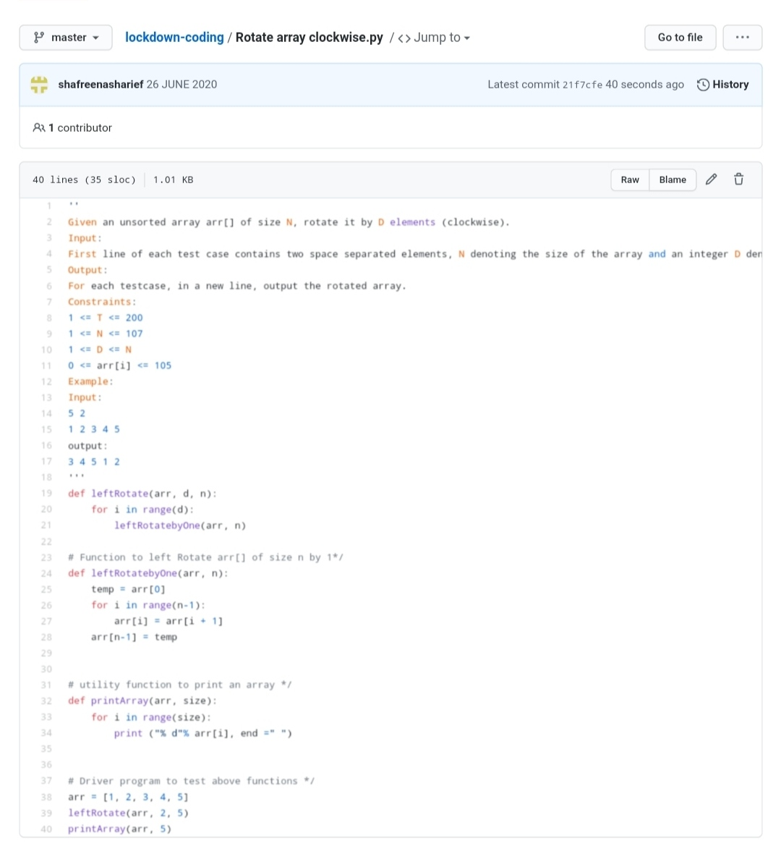

***EXTRA ACTIVITIES:***

Today I attended Online training on Cyber security from morning

9:00-11:00Am. Two Quizzes are conducted.

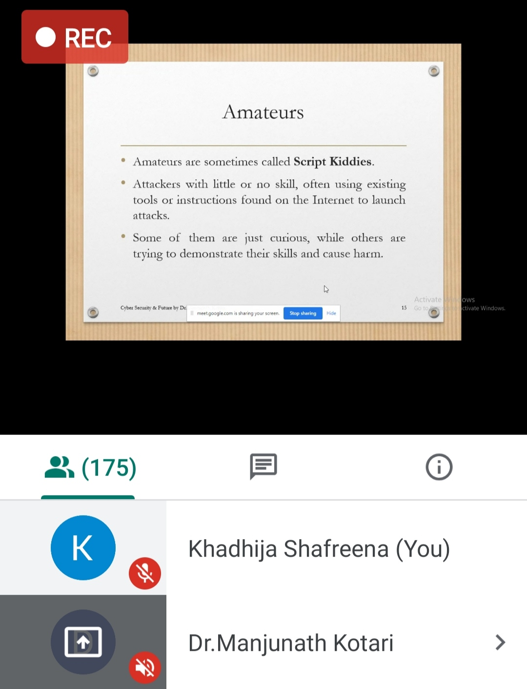

**SOLUTION** : I have uploaded the solution of the above 2 coding problems in my GitHub repository.

[http://shafreenasharief / lockdown-coding](http://shafreenasharief / lockdown-coding" \o "http://shafreenasharief / lockdown-coding)

[http://shafreenasharief / locked-down--certification-course](http://shafreenasharief / locked-down--certification-course" \o "http://shafreenasharief / locked-down--certification-course)

[http://shafreenasharief / Daily\_Report](http://shafreenasharief / Daily_Report" \o "http://shafreenasharief / Daily_Report)